NAME: _______________

Score /40

Task 4 GEHBY HEART DISSECTION – 6%
The heart is a very important component of the circulatory system as it is responsible for pumping blood around the body. The heart has many different structures that are responsible for different tasks.

TASK: Your task is to carry out a successful dissection, locate important components of the heart and complete all questions.

- Label the diagram below of the heart (some words may be used more than once)
(7 marks)
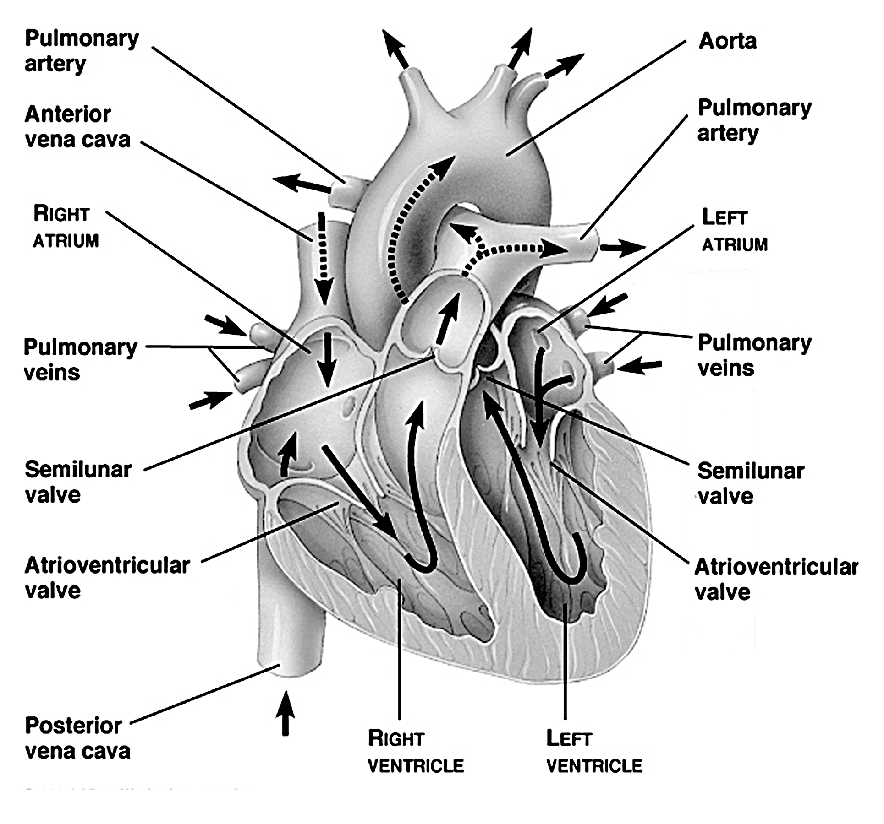

A: _______________
B: _______________
C: ___________
D: ___________
E: ___________

G: ___________
H: ___________
I: ___________
J: ___________
K: ___________
L: ___________
M: ___________
N: ___________
O: ___________
- Place your heart on the dissecting tray with the major blood vessels furthest away from you with the apex close to you. Locate the external features of the heart: You may need to probe some of them to work out where they go to/ come from.
- Aorta
- Right atrium
- Left atrium
- Right ventricle
- Left ventricle
- Pulmonary artery
- Vena Cava.
- Coronary artery
- Poke a blunt seeker down the aorta. Describe what it looks and feels like. (2 marks) ____________________________________________________________________________________________________________________________________________________________________________________________________________
- Why do you think the aorta looks and feels like it does? (2 marks) ________________________________________________________________________________________________________________________________________
- Locate the coronary artery (artery running toward the apex on the outside of the heart- usually with a lot of fat around it). What is the function of the coronary artery? (1 mark) ________________________________________________________________________________________________________________________________________
- What would happen if this artery gets blocked? (2 marks) ________________________________________________________________________________________________________________________________________
- What do you think would be the cause of any blockages in these arteries? (2 marks) ____________________________________________________________________________________________________________________________________________________________________________________________________________
Use the scalpel- you are ready to make an incision in the heart. Start at the bottom of the heart at the apex, make a cut adjacent to the coronary artery cutting towards the top of the heart. You will be cutting into the ventricles. Open up the heart to expose the internal features.
- There are flaps of skin located inside the heart separating the atria and the ventricles, anchored by fibrous cords. What are these cords called? (1 mark) _________________________________
- Why does the heart have these? (1 mark) ________________________________________________________________________________________________________________________________________
- Look at the walls of the right and left sides of the heart. What do you notice? Can you provide a reason for why they are so different? (2 marks) ____________________________________________________________________________________________________________________________________________________________________________________________________________
- Look at the atria- What do they look and feel like? (2 marks) ________________________________________________________________________________________________________________________________________
- Why do you think they feel and look different to the ventricles? (2 marks) ________________________________________________________________________________________________________________________________________
- Observe any other features of the heart you can see and try to work out the path which blood takes through the heart. Using the terminology in the box below, write the correct sequence of blood through the heart. (9 marks)
  - Superior Vena Cava
  - _____________________
Left atrium
Right atrium
Left ventricle
Right Ventricle
Aorta
Lungs
Pulmonary Artery
Pulmonary vein
Body

  - _____________________
  - _____________________
  - ____________________
  - ____________________
  - ____________________
  - ____________________
  - ____________________
  - ____________________

-Tidy up your area and place all equipment back in the trays-

- How are oxygen and carbon dioxide transported in the blood? (7 marks)
Include:
- Which blood vessels are involved in which order (to heart/away from heart) (2)
- A description of what pulmonary circuit does (1)
- A description of what the systemic circuit does (1)
- Where, how and why gas exchanges occur (3)

____________________________________________________________________________________________________________________________________________________________________________________________________________________________________________________________________________________________________________________________________________________________________________________________________________________________________________________________________________________________________________________________________________________________________________________________________________________________________________________________________________________________________________________________________________________________________________________________________________________________________________________________________________________________________________________________________________________________

